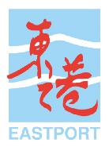

News Release – For Immediate Release
Singapore, 4 August 2021

Leading Maritime Companies Invite Tertiary Tech Talents to
Solve Real-world Challenges
Inaugural Maritime Singapore Connect (MSC) Maritime Digital Challenge offers platform for Singapore’s university and polytechnic students to pit their tech skills against real-world challenges from leading maritime companies

The Singapore Maritime Foundation today launched the inaugural Maritime Singapore Connect (MSC) Maritime Digital Challenge, a case competition that allows students with a passion for technology from Singapore’s universities and polytechnics to pit their knowledge and skills against real-world challenges posed by leading companies.
The 2021 edition sees participation from the following three companies:
COMPANY | CHALLENGE SYNOPSIS
Eastport Maritime  A leading global shipbroking and consultancy company based in Singapore. | Use gamification to develop an interactive and engaging learning platform to onboard new hires and existing employees taking on new roles.
Kanda  A leader in developing digital learning applications that enable collaborative teamwork across platforms such as using virtual reality to make training in heavy industries more effective and cost efficient. In 2021, Kanda has also become a member of the Eastern Pacific Accelerator powered by Techstars. | Use virtual reality technology and game-based learning to train users to conduct industrial procedures such as operating a fuel gas supply system.
Torvald Klaveness  A Norwegian shipping company that has various business units which includes dry bulk, combination carriers, ship management, Klaveness Digital, and ZeroLa. | Create an app for seafarers to input clean data to develop insights for sustainable shipping.

For each challenge statement, the winning team will win a cash prize of $3,500 while the first runner-up and second runner-up will win cash prizes of $1,500 and $1,000 respectively. In addition, students will gain valuable opportunities to be mentored by maritime industry professionals and clinch internships with the participating companies.
Registration opens from today to 19 August at www.maritimesgconnect.com. Students from Singapore’s tertiary institutions are invited to form teams of between two to five to tackle the challenge statement of their choice, and submit their proof-of-concept on 10 September.
Participating companies will evaluate the submissions, and the shortlisted teams will be announced on 29 September. From here, the companies will mentor the shortlisted teams in the lead-up to the grand finals on 13 November.
“Transformation in the maritime industry—spurred on by digitalisation and decarbonisation—is gathering pace. From a talent perspective, this creates new career opportunities in technology and sustainability—fields not traditionally associated with maritime. The MSC Maritime Digital Challenge allows tertiary tech talents to connect with the dynamic maritime ecosystem, put their skills to the test, and gain valuable experience to stand them in good stead for their career,” said Ms. Tan Beng Tee, Executive Director, Singapore Maritime Foundation.
“Eastport is excited to be part of the inaugural MSC Maritime Digital Challenge. Digital transformation is profoundly impacting the nature of work and skills, and without exception, maritime businesses have to adapt swiftly. Through this Challenge, we hope to translate the perspectives of millennials into solutions for a fresh take to connect Eastportians to one another and the company, onboard new hires effectively and empower existing staff with learning opportunities to gain relevant skillsets for success in the digital work era,” said Ms. Sharon Teo, General Manager, Eastport Maritime.
“Kanda is honoured to be invited to participate in this challenge. We see this as a great opportunity to get a fresh perspective on our business and potentially find our next employees in Singapore through this collaboration with the Singapore Maritime Foundation,” said Mr. Kristian Andreasen, CEO, Kanda.
“Digitalisation is crucial for maritime enterprises to adapt to ‘the new normal’; industry leaders are calling on young talent to create solutions that will benefit the industry as a whole,” said Michael Jørgensen, Head of Dry Bulk, Torvald Klaveness.
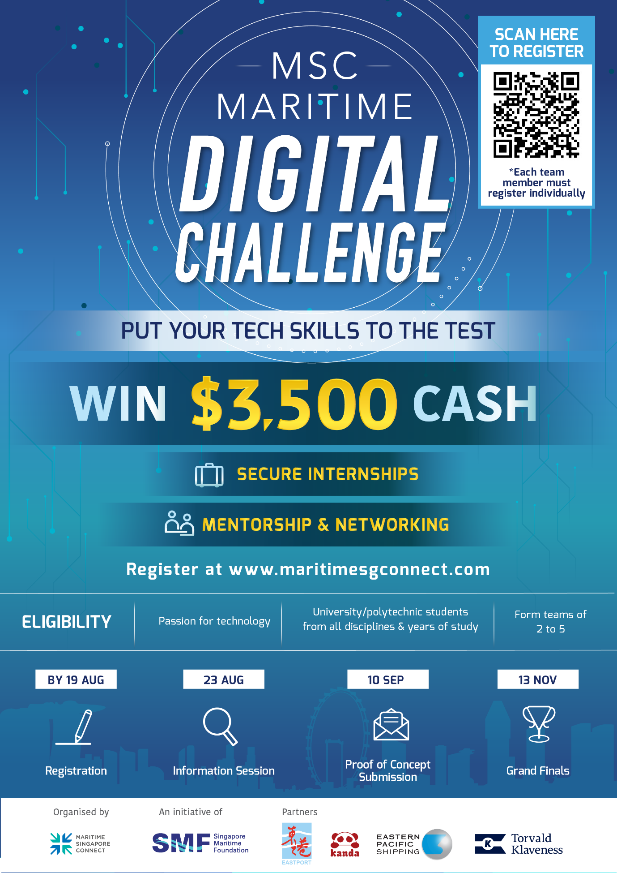

-- Ends --
About the Singapore Maritime Foundation
Established in 2004, the Singapore Maritime Foundation (SMF) is a conduit between the public and private sectors to accomplish the twin mission of developing and promoting Singapore as an International Maritime Centre (IMC); and to attract, engage and grow a talent pipeline to position Maritime Singapore for continued growth.
The Maritime Singapore Connect (MSC) Office operates Singapore’s only dedicated maritime careers portal at www.maritimesgconnect.com and provides job matching to collect talent with opportunities.
For details, visit www.smf.com.sg

About Eastport Maritime
Eastport has been established since 1980, and we have become a leading global shipbroking and consultancy company that provides a wide range of services to a large and diverse clientele across the globe. With our headquarters in Singapore and offices in all major shipping centres in the world, we are able to serve an array of industries such as Liquid & Gas Chemical, Vegetable Oil & Biofuel, Crude Oil & Petroleum Product and Dry Bulk.
For details, visit www.eastportmar.com

About Kanda
Kanda is a company headquartered in Denmark that specializes in developing digital learning applications that enable collaborative teamwork across platforms such as using virtual reality to make training in heavy industries (maritime, energy, airline, manufacturing) more effective, and cost efficient. In 2021, Kanda has also become a member of the Eastern Pacific Accelerator powered by Techstars.
For details, visit www.kanda.dk

About Torvald Klaveness
Torvald Klaveness is a Norwegian shipping company that was founded 75 years ago. We have various business units which includes dry bulk, combination carriers, ship management, Klaveness Digital, and ZeroLab. The company’s Dry Bulk unit is a leading digital operator and service provider to the global dry bulk industry. Through Klaveness Combination Carriers, the company has a unique concept of combination carriers taking an active part in the transition to low carbon shipping, and through Klaveness Container Klaveness provides container feeder vessels to various operators. Klaveness Ship Management manages the owned vessels from an environmental, technical and commercial standpoint and Klaveness Digital has developed the world’s leading platform for managing seaborne logistics.
For details, visit www.klaveness.com

Media Contacts

David Lee
davidlee@sgmf.com.sg
+65 9119 8044

Angelene Yong
angeleneyong@sgmf.com.sg
+65 8299 2330

